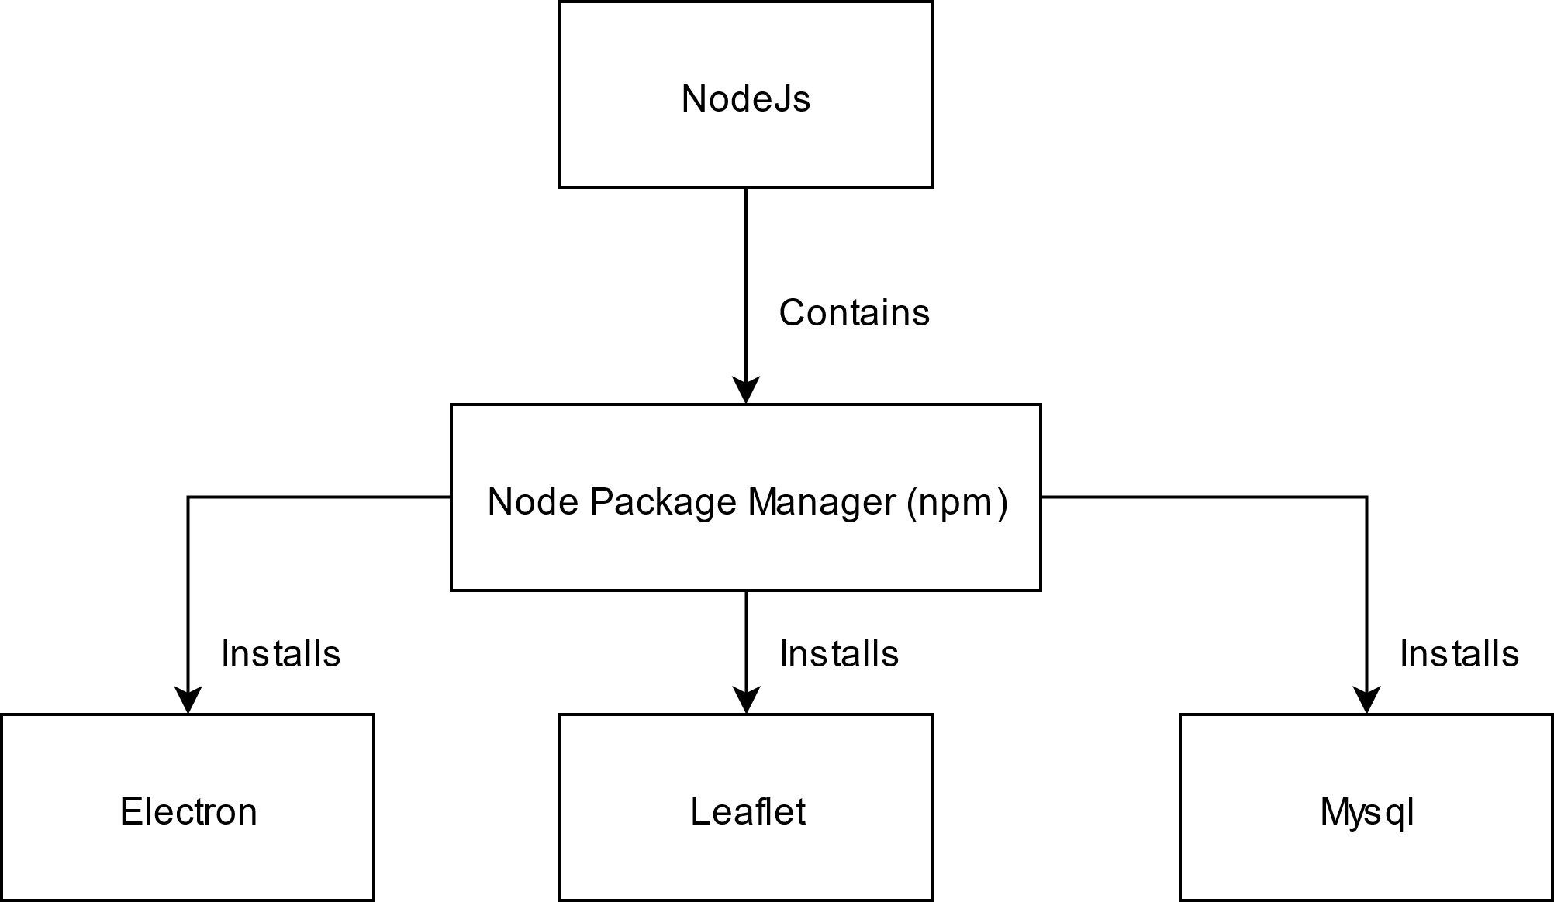

***NodeJS*** is a cross-platform runtime library for ***JavaScript***. It also contains the Node Package Manager (**NPM**) that provides open-source libraries like ***LeafletJs***, ***ElectronJs*** and others.

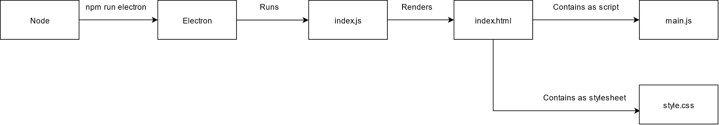

The runtime execution of the program starts with ***Node*** to execute a script using ***NPM***. An example according to the diagram above.

1. Use ***Node*** to start ***Electron*** with the command ***npm run electron.*** This command refers to a script in the ***package.json*** file with the same name ‘electron’ that starts up the program.
2. ***Electron*** executes the ***index.js*** file that contains the code to render the ***UI/index.html*** file on the screen inside of a window. The window itself is the exact same as any chrome browser window including the developer tools toggled with (***CTRL + SHIFT + I***).
3. The ***UI/index.html*** file contains the structure of the program’s UI elements. It also loads extension libraries from the ***Plugins/*** directory.
4. The ***UI/style.css*** describes the style of the html elements on the screen such as the color, height, width and visibility among other things.
5. The ***js/main.js*** is the main source code for the program. It contains all the logic for how the program runs and is used to show the map as well as render and update the data on it.